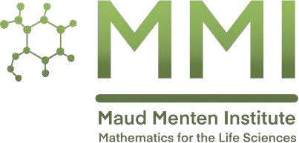  

***Maud Menten Institute / Mathematical and Statistical Biology Seminar***

# Monday, April 7, 2025

**2:00pm CT**

**University of Manitoba – 225 St. Paul’s College**

-or-

## [Join Zoom meeting](https://umanitoba.zoom.us/j/66960493994?pwd=xahlt1zaWR3DTgL0eDsdoMbMu0JC7Q.1)

Meeting ID: 699 6049 3994

Passcode: 900153

In Victoria: Attend the **UVic watch party (12pm PT)**  Engineering/Comp Sci-130

**Roderick Melnik**

Mathematics Department Wilfrid Laurier University

**Nonlocal Models in Life Sciences: Applications in**

**Biosocial Dynamics, Ecology, and Brain Studies**

Life is a nonequilibrium phenomenon where nonlocal processes play a prominent and increasingly important role. Nonlocal models have emerged as a robust mathematical framework for capturing interactions across spatial and temporal scales in the life sciences. In this talk, we explore their applications across three key domains of the life sciences: (i) biosocial dynamics, where nonlocal interactions can assist in better describing cooperative behaviours, social contagion, disease propagation, and decision-making in populations; (ii) ecological models, where long-range interactions influence species competition and environmental heterogeneity; and (iii) neurodegenerative disorders, where nonlocality plays a crucial role in modelling protein misfolding, toxic protein spread, and neuronal connectivity disruption in diseases such as Alzheimer’s and Parkinson’s. By integrating novel perspectives, we highlight the unifying role of nonlocality in describing emergent behaviours across biological scales and address the mathematical challenges in modelling complex systems. Our findings suggest that nonlocality is essential for understanding the relationship between structure and function in living systems, with significant implications for disease progression, brain studies, population dynamics, and ecosystem stability.